**Using a Web-Based Digital Islamic Library as an Alternative in Searching for Islamic References**

**Faridah Hilmirhani1, Rahmat Iqbal2, Eni Amaliah3\***

1, 2 UIN Raden Intan Lampung

)* Corresponding Author, Email: [faridahhilmi04@gmail.com](mailto:faridahhilmi04@gmail.com), [rahmatiqbal@radenintan.ac.id](mailto:rahmatiqbal@radenintan.ac.id), eniamaliah@radenintan.ac.id

Received: Oktober 2023; Accepted: Oktober 2023; Published: Desember 2023

**Abstract**

This study discusses the use of digital Islamic libraries, where digital Islamic libraries are one of the programs of PKH (“Pusat Kajian Hadits”/Hadith Study Centre) based in Jakarta. There are about 8000 volumes of books with 3600 titles which can be accessed free of charge. This research was conducted with the aim of obtaining a detailed description and description of the use of web-based digital Islamic libraries. In this study using descriptive qualitative research methods, by utilizing library sources, namely journal articles and the web. The results of this study are that the use of digital Islamic libraries is very easy to access because the web can be accessed anywhere, and this web uses Indonesian so the search process is easier and can be understood by the public. This application of digital Islamic libraries provides a convenience for lovers of Islamic religious books such as fiqh, akidah, usul fiqh, morals and other books.

Keywords**:** Digital library, digital Islamic library, Religious Books, Islamic References

**INTRODUCTION**

Libraries should transform in order to provide maximum performance to their users. The change from conventional libraries to hybrid libraries to the point of digital libraries. It begins with a change in the physical form of library materials into a non-physical or digital form that can be accessed anywhere, anytime and using any device. With the development of information technology, libraries can utilise it by creating digital libraries. Not only are changes in the form of digital collections required, but the form of services provided to users by the library should also have followed the changes in the 4.0 era, besides that the services provided also require good information communication provided by library managers to users so that they can be used optimally by their users.(Iqbal et al., 2021)

Al-Qur'an and Hadith are two important foundations in Islam. Without the hadiths, the Qur'an cannot stand alone because the hadiths are intended to explain the Qur'an. At the beginning of its development, hadith and Al-Quran were only collected and memorized, then entered the documentation period, when hadith and Al-Quran began to be written down on paper. Many works of commentary and books have been written, which have become reference books for every study of the Qur'an and hadith for later generations. However, when studying hadith, many problems often arise because of the difficulty of accessing the data. Hadith also has complex content and requires a lot of data and references from previous books which are often not studied.

In the heyday of Islam, the library was a means of learning that eventually Muslims built a civilization and glory that lasted for centuries. There is a lot of information and knowledge that is not documented by Muslims and is simply forgotten. As a result, the order of life for Muslims, both in the economic, political, social, cultural and other fields of life, has become stagnant. So that in the end Muslims only become followers of developed countries, which in this case is the western world. Even though we understand that the development of western world was achieved through the wisdom of knowledge taken from Muslim learning centers, such as libraries.

The explanation above shows how important libraries are in the development of a country. In this case, the amount of knowledge, information and documentation provided by the library plays a major role in community empowerment. Much literature shows that the library is a place of learning activities, activities that are very similar to schools. The role and role of this library are widely used by libraries in developed countries such as England, Australia and Canada. Many libraries have been converted into learning centre or resource centre. This indicates that the library played during the heyday of Islam was very important and representative for the development and progress of society.

Changes in the library system have now spread to Islamic libraries, which have entered the contamination of information technology or the digitalisation era in all search systems in Islamic libraries. There has been a shift in the search culture of almost every society in searching for information inseparable from the use of Google or social media as a tool for searching information, sharing information or interacting. Because information has become a primary need among the community. Every aspect of life at this time is always contacted with the availability of information and information technology. This shows that information technology has gained an important place in people's lives. This fact shows that many people in searching for information use information technology, either using google media, social media or digital libraries.(Iqbal et al., 2021)

Libraries have evolved over the last few decades to eventually create the concept of digital libraries, software that replaces library processing and manual management. All existing data is managed digitally by library software. Digital library is a further development of website technology. The use of web browsers is what causes digital libraries to have similarities with websites, especially their features.

**RESEARCH METHODS**

The method used in this research is a qualitative descriptive research method, a qualitative research method is a research used to examine the conditions of natural objects, where the researcher is the key instrument[1] Sources of written references that can be utilized in research include reading materials, journal articles, magazines, yearbooks, bulletins, annual surveys, bibliography, handbooks, and guidebooks. This research utilizes literary sources, namely journal articles and the web [2]. Qualitative data analysis was used as a data analysis technique in this study. This is done with the aim that we can explain it more accurately.

**RESULT AND DISCUSSION**

The Digital Islamic Library is one of the PKH (“*Pusat Kajian Hadits*”/Hadith Study Center) programs based in Jakarta. The Center for Hadith Studies is a special institution that studies the Al-Qur'an and Hadith in depth, using the media to spread the hadiths of the Prophet Muhammad SAW. Considering that currently the study of hadith is still relatively weak compared to the study of other scientific fields. This can be seen from the lack of experts on the Al-Qur'an and Hadith, and the low interest of students to study the contents, as well as the very small collection of books. This is one of the reasons for launching the Islamic digital library program.

Accessing the Digital Islamic Library is also very easy because the website can be accessed from anywhere and this website uses the Indonesian language so that the search process becomes easier and understandable for the public. The existing books are also in pdf format, which is in the form of the original book, which can turn pages, like turning the pages of a book. These books can also be stored on the user's device to access them again when they are offline.

This website has more than 3,000 book titles from several groups of Islamic studies, with a total of 3,000 books, there are more than 6,000 volume titles. The books are divided into several groups, namely:

|  |  |
| --- | --- |
| Number of Book Titles | 2,770 (no repeated prints) |
| Number of Volumes | 6,100 Volumes |
| Number of Pages | 2,875,447 Pages |
| Major Fields in Digital Islamic Library Applications :   1. Al-Qur'an: 758 Volumes 2. Al-Qur'an: 63 3. Knowledge of the Qur'an: 192 4. Interpretation: 490 5. Hadith: 2,066 Volumes 6. Hadith Science: 135 7. Rijal Hadith: 258 8. Matan Hadith: 1673 9. Aqidah: 382 Volumes[3] 10. Fiqh: 1,013 Volumes 11. Usul Fiqh: 253 Volumes 12. Languages: 456 Volumes 13. Da'wah: 58 Volumes 14. Tarbiyah: 40 Volumes 15. History: 712 Volumes 16. Einsoclopedi: 99 Volumes 17. Others: 209 Volumes | | |

The Kitab category is one form of information retrieval machine provided by digital Islamic library institutions to make it easier for users to get the collections they need effectively and efficiently. Online Public Access Catalouge, often known as OPAC, is a form of search engine in all libraries that have library automation. similar to OPAC, in digital Islamic libraries

using the name search is a transformation of services provided by Islamic libraries where catalogues used to be always identical to books or paper containing bibliographic information from a book, arranged by subject, alphabetical or date of publication of the collection itself. By transforming the manual catalogue into an online catalogue, it makes it easier for users to get book information about the collection of library materials that readers want to read and enjoy(Amaliah et al., 2022).

1. **Digital Islamic Library Display (PID)**

By using the Indonesian language, users can easily understand web content and easily find what they are looking for without having to bother understanding the existing tabs. The main page has a search function for the book we want to read in the right corner of the page, visitors can directly enter the book they want to read in that column to save time. The home page also has books that are frequently accessed by visitors, divided into several types of collections, such as books of interpretation, books of jurisprudence, books of hadith, books of nah, books of dhikr, Arabic dictionaries, and maps. There is also some information about the authors, publishers and web supporters. It can be found in the “About Us” section, which is third after the “Library” tab on the main page. This display can be seen in the image below.

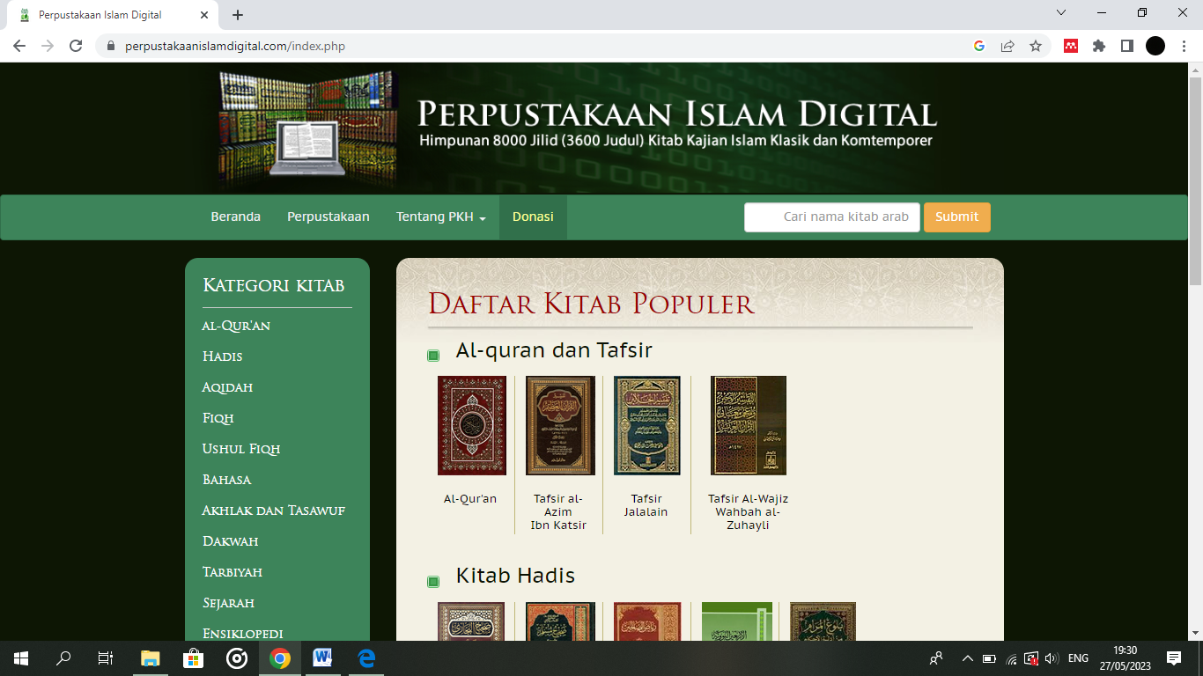

Gambar: Menu Dasbor

The main page is a menu that directs visitors to another menu. This homepage contains images that represent the total content of services provided. On the main page, digital books are grouped according to the desired discussion so that visitors who want to search for digital books can find them directly based on the existing categories. Then click the button to view the digital files.

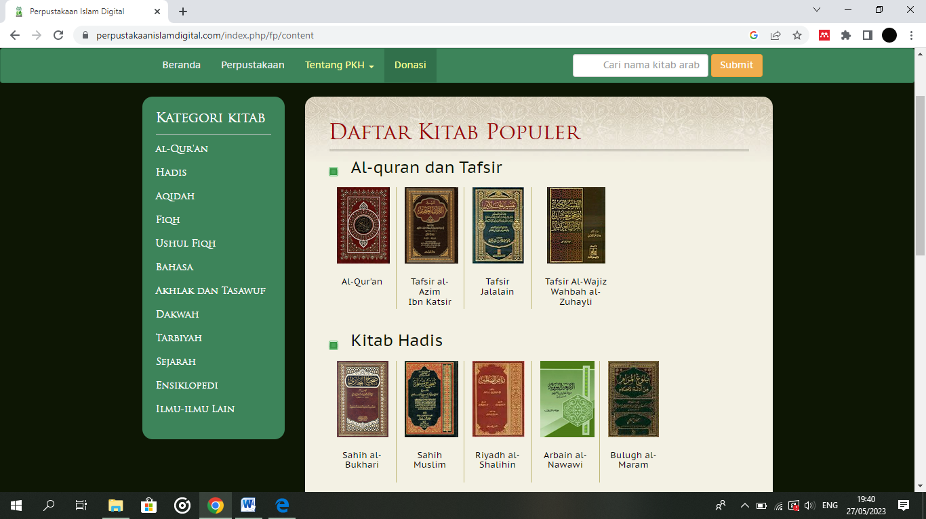

Gambar: Kategori Kitab

The field categories on this website contain lots of books covering various fields and various streams. Information search technology is now spreading in almost every field, and libraries are no exception. Islamic libraries are no exception. For millennials, knowledge is important to them. As a result, libraries must keep up with the times and always be selective with all types of data and information processed, information must always be accurate and relevant in order to avoid unimportant information. Islamic libraries must always be able to integrate with the times that are currently heading towards digitalisation. Libraries are increasingly developing, of course, supported by the rapid advancement of information technology. The demands and paradigms of millennial society make changes to libraries, conventional libraries are now starting to be developed with digital libraries, moreover it is not uncommon for people to think that digital libraries are considered easier to access and reach(Shafa Shafina Putri Andita, 2022).

Among others are: A l-Qur'an: (758 volumes), including: Al-Qur'an Mushaf, Al-Qur'an Index of Tajwid Science, Qiroat Science, The Virtue of Al-Qur'an. Methods of Teaching and Memorizing the Al-Qur'an, Ulum Al-Qur'an, Branch of Al-Qur'an Studies, Language Studies, Interpretation Methods and Methodology, Classical Interpretation, Contemporary Interpretation, Ahkam Interpretation, Thematic Interpretation, Criticism of Problems and Suggestions, Tobaqoh Qurro' and Mufassir.

Hadith: (2066 volumes), includes: Classical Hadith Science, Contemporary Hadith Science, Nazm Hadith Science, Special Studies on Hadith Science, Illal Hadith, Rijal Hadith Theory Studies, Companions Biography. Friends and Tabi'in, Book of Asma', Book of Jarh Wa Al-Ta'dil, Book of Sahifah, Book of Ajza. Book of Amali, Book of Musnad. The Muwatta Book. Sahih Book, Mushannaf, Mu'jam Book. Mustadrak book. Mustakhraj Book. Sunan Book. Thematic Books, Collections of Hadith Character Values, Collections of Hadith Strength Values, Combined Books, Al-Zawa'id Books, Hadith Encyclopedias, Hadith Indexes, Language Studies, Gharib Hadith, Syarh Hadith, Books of Takhrij Al-Aqidah Al-Wasithiyyah, Books of Al- Faith, Book of Al-Tawhid, Book of Takhrij.

Aqidah: (382 Volumes), includes: The Book of Al-Sunnah, The Book of Al-Syari'ah, Contemporary Books, Questions and Answers, Allah Rabb Al-Alamin, Angels, Prophets and Messengers, Death, Punishment of the Grave, Doomsday, The Hereafter, Qodo' Qodar, Alam Unseen, Comparison of Schools, Comparison of Religions, Studies and Polemics, Comparison of Religions, Position and Role of Intellect.

Fiqh: (1013 Volumes), includes: Fiqh of the Hanafi School, Fiqh of the Maliki School, Fiqh of the Syafi'i School, Fiqh of the Hambali School, Fiqh of Comparison , Fiqh of Thaharah, Fiqh of Prayer, Fiqh of Bodies, Fiqh of Fasting, Fiqh of Hajj, Fiqh of Food and Drinks , Ahwal Syakhsiyah Fiqh, Property Fiqh, Ikhtilat Fiqh, Women's Fiqh, Political Fiqh, Social Fiqh. Fiqh of Arts and Sports, Fiqh of the Environment. Fiqh of [4]International Law, State/Lajnah Fatwa, Ahmad Ibn Hambal Fatwa, Imam Al-Syatibi Fatwa, Ibn Taimiyah Fatwa, Ibn Rushd Fatwa, Al-Syaukani Fatwa, Al-Hindiyyah Fatwa, Ali Al-Sheikh Fatwa, Al-Utsaimin Fatwa, Fatwa Al-Sa'diyyah, Fatwa Al-Albani, Fatwa Bin Baz. Fatwa Ali Al-Saghdi, Fatwa Prayer, Fatwa Fasting, Fatwa Hajj and Umrah, Fatwa Ikhtilat. Tobaqoh Fuqoha Hanafi, Tobaqoh Fuqoha Syafi'i, Tobaqoh Fuqoha Hanabilah.

Usul Fiqh: (253 Volumes). includes: Classical Books, Contemporary Books, Study Books and Polemics

Languages: (456 volumes), including: Books of Dictionary, Books of Language and Literature, Books of Balaghah, Books of Nahwu and Sorof.

Da'wah: (58 volumes), includes: Books on Da'wah Methods, Books on Dialogue Ethics, Books on Sermons at the Al-Haram Mosque, Books on Sermons at the Al-Nabawi Mosque, Books on Da'wah Materials.

Tarbiyah: (40 Volumes), includes : Books on science and educational theory, Books on children's education, Books on education for the ummah, Books on educational problems.

History: (712 Volumes), includes: History, World History, History of the Prophets, History of Companions, History of the Ottoman Daula, General Islamic History, History of the Crusades, History of Makkah. History of Medina. History of Baitul Maqdis, History of Damascus, History of Baghdad, History of Iran, History of Egypt, History of Africa, Arab Countries, Islamic Countries, Other Countries, Years of Death of Figures. Biography of Companions, Biography of Tabi'in and Atba', Biography of Mazhab Imams, Biography of Scholars of Hadith, Biography of Ibn Taimiyah, Biography of Al-Qasimi, Contemporary Scholars, Biography of Leaders, Historical Notes.

Einsoclopedia: (99 Volumes), includes: Books of Maps and Books.

General Encyclopedia[5]

Others: (209 Volumes), includes: Islamic Economics, Medicine, Islamic Psychology, Islamic Sociology, General Sociology, Islamic Insights.

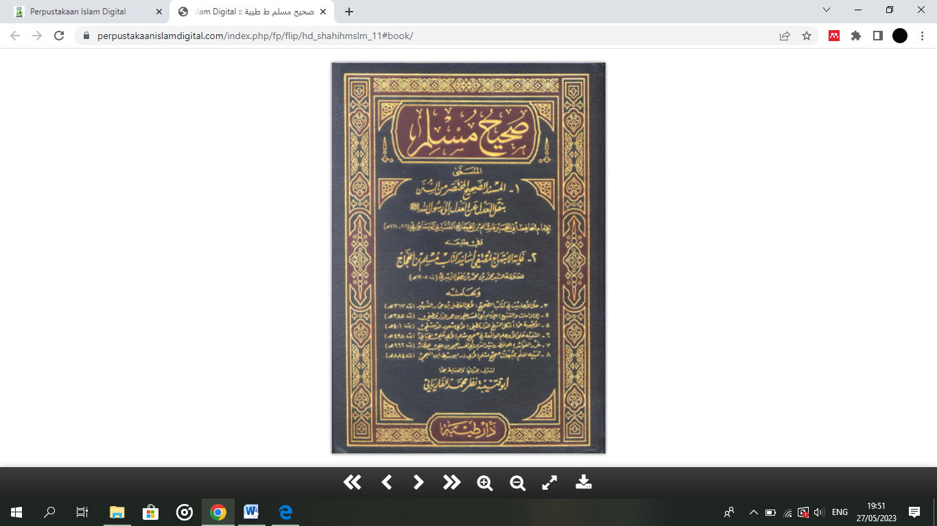

Then in the picture above there are books in the hadith collection, in each field containing books related to the theme opened. When we click on “view book”, we can open the book as a digital book or as a pdf file. The appearance when opened as a digital book looks like in the image below, as if we opened a real book with pages that can be turned over and it also looks like the original book so that we can read the contents comfortably. We can enlarge or reduce the appearance of this digital book as we like, so that the sentences in the digital book can be read easily.

To directly open the page you want, simply type the page in the tab section below in the form of a number, then the user can quickly open this page without going through the pages one by one, the user can also open the digital book from behind or quickly return to the start page. . Besides being able to turn book pages like the original book, digital books on the web can also be downloaded so that we can easily access them again when needed without having to use the internet.

How to download it is quite simple, visitors only need to open the book they want to read, then there is a download book button on the far right of the tab below the book we are currently opening.

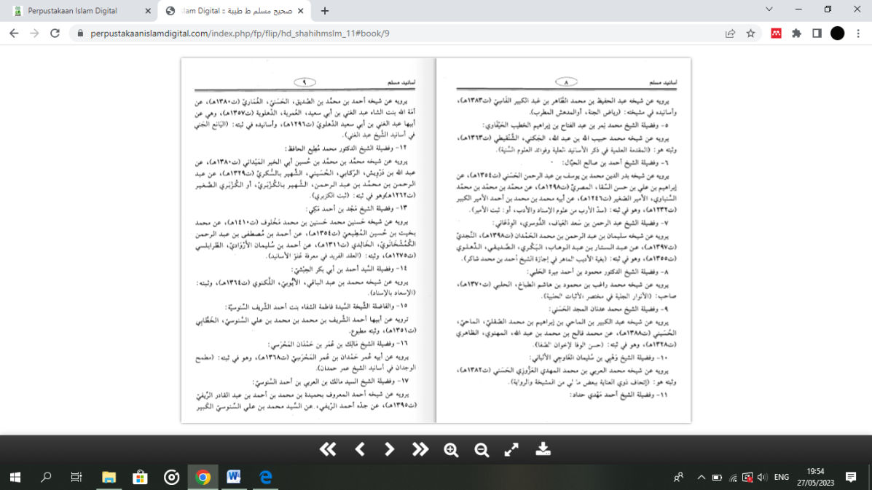

Gambar: Isi File dalam Kitab

1. **Data Sources on the Digital Islamic Library**

All sources obtained are sources from [www.waqfeya.com](http://www.waqfeya.com) . This site is a waqf site, which means that the book displayed is public property because it has been donated so there is no copyright. Because of endowments, the authors make this program open, in which the authors do not block and do not register copyrights, the authors only register their copyrights with the aim of closing the possibility of people abusing this program.

The collection of library materials in the digital Islamic library contains electronic books, this electronic book can be enjoyed by users by simply clicking on the library material they want to read, then immediately the information that the reader clicks will come out.

In this Islamic library, the library material has 12 categories with each category containing several sub-subs that contain according to the initial category that is clicked.

Such as **Al-Qur'an** library materials in the first category contain 3 sub including Al-Qur'an (in the category of the Qur'an in the first sub, namely the Qur'an contains an understanding of a mushaf or sheets of the Qur'an, followed by the index of the Qur'an, enhanced by the science of tadjid, this science teaches how to sing the recitation of the Qur'an properly and correctly so as to make those who listen comfortable and calm. also strengthened by the science of qiroat and methods of how to teach and memorise the Qur'an and its manners), science of Al-Quran(In this sub-section there is information on the Ulum of the Qur'an which discusses in classical and contemporary terms, there is also information on the Branch of the science of the Qur'an which discusses asbabun nuzul, the study of verses and surahs, stories in the Qur'an, advice and input contained in the Qur'an and I'Jaz, Isra'ililyyat and nukat in the Qur'an). and Tafsir Al-quran (in the interpretation section there is some information that is quite important for users who want to explore science or information in the field of interpretation of the Qur'an. because in this interpretation section there is some information, including methods/methodology, classical interpretation, contemporary interpretation, thematic interpretation, interpretation of Juz, Surah and certain verses and tadabur al-qur'an).

While the **hadist** category contains 3 subs with the contents of hadist science (In the hadist category with hadist sub-science contains some very important information for library users in improving knowledge and information on hadist science, including discussions of classical hadith, contemporary hadith, hadist Nazm, besides that there are also specific special discussions, namely ilal hadith, methodological studies, figures and contributions, studies of special hadist themes and studies one and two from the hadist science section.), hadist rijal (In the hadith category with sub rijal hadith contains some information that can increase knowledge for users in utilising or optimising digital Islamic libraries as a means of retrieving information in the digital era, among them there is a theory that discusses the basic theory of a hadith and the methodology used, then discusses the biography of the companions and the biography of the tabiin, there is also information about kitab al-asma, besides that there is information on kitab al-jarh wa al-ta'dil and tobaqoh and biographies of hadith scholars. This chart is enhanced by the al-jarh wa al-ta'dil dictionary to provide convenience for Islamic library users in improving user access to information), hadish matan (in the sub discussion with the theme of matan hadist contains some information that is not less important for the visitors of the Islamic library who want to enhance his knowledge in the science of hadist, among them discussing about hadist in the sub matan also offensive about groups of hdist such as thematis, hadist value of character, value of strength, combination of books of hadis, book al-zawald and ghartbist. Besides it is also done the investigation of hadists using takhriist, bhadhhist, hadith, language studies and also equipped with index and encyclopedia hadist that became a reinforcer in the information hadist for users in finding hadist information.

The next category in software applications digital Islamic library regarding **Aqidah**, in this category contains two discussions, namely regarding Islam and comparative religions, the position and role of reason. The first discussion about Islam contains information that is studied in general or specifically, if it is general it discusses Allah Rabb al-Alamin, Angels, Prophets and Messengers, messengers of Allah, death and the punishment of the grave. While the special discussion contains discussion of the Last Day, the Afterlife, Allah's Qodo' and QOdar, the Unseen Realm, comparison of schools of thought, comparison of religions as well as studies and polemics that always occur in society. Meanwhile, to discuss religious comparisons, we only study two beliefs, namely Jews and Christians.

Further discussing the category about **Fiqih**, in this article discussing some of the science that is very needed for the seekers of information in improving the science of fiqih her, among them discussing about fiqh mazhab, fiqih mazhab performed information surgery of four mazhab scholars who became the penitent for the Muslim people in performing worship that they did, among others discussing mazhib hanafi, mazhabi hambali, mazab syafi'i and mazhob hambali as well as other mazhabe-mazhab scholar. In addition, the Islamic library also provides information about the comparison fiqh in a concise and compact way so as to provide users with easier information in enjoying the information presented so that discussions about the old and new fiqih books can be delivered to users, in addition there is also a discussion in the form of thematic fiqah that deals with Fiqih Thaharah, Fiqih Prayer, Fikih Jenazah, Ficih Puasa, FiQih Hajj and Umrah, Food and Beverage FiQih, Fiqi Ahwal Syakhsiyah, fiqih Harta, Fichih Ikhtilat, Fiqih women, Political Fiqih, Social Fiqih, Fiqih Art and Sports, Fiqih Environmental Life, Fiqih International Law, Fiqih Jihad, Fiqih Khitan and Fiqih Economic. In the fiqih category there is also an examination of a fatwa, namely fatwa ulama, fatwa thematic, state fatwa and lajnah as well as fatwa fikih, in this category is closed with the discussion of Tobaqoh Fuqoha that includes in the fuqoha hanafi, syafi'i and fqoha hanabilah.

The next category discusses about **Ushul Fiqih**, in this category studies several subjects namely Classical, Contemporary presented with the study and offensive about the controversy that often occurs in the community in the distinction of the work of worship.

This category deals with **languages**, in this discussion we focus on languages and literature that is the history and development of the dates of the Arabic Adab, books al-lughah, Arabic adab, natsar books, the Syi'ir books and the book al-urudh. Besides this category also studies of nahu and sorof, this study is not less important than the study of the previous categories because in the study in this sub category of languages we will get the science in the spelling that we often encounter when we read the books in Arabic language namely the science of Nahu and Sorof, on this sub contains some studies in the classic nahu books, and the contemporary Nahu books aimed at enhancing the readers' insight in the process of language changes and sentences that often occur when we are reading books in the language of Arabic, next the books of sorofs, nahu book and sarof, and i'rob some studies around nahu, so that we are complete to obtain information in this category of knowledge. We will not forget that we will gain insight into the world and the people and be perfected with dictionaries and diwan.

The categories of **morals and Sufism** are discussed separately, meaning that the discussion of morals and Sufism is also discussed separately. The discussion on Sufism contains some information regarding istiqamah, the concept of happiness, Sufism, Sufism, asceticism, the book Ihya Ulum al-din and recognizing sin and this category is also equipped with a collection of prayers that readers can use and is equipped with dhikr and prayers.

Below we will give an explanation of **the teachings** and ethics related to the methods of teaching, the ethics in dialogue with the listener, the material of teachings that we will tell to the society with the hope of a teaching and that we save can be accepted so that produces a change to a society to a better life, the next about the teaching, in this sub give explanations about ethics, and fiqih khutba and khatib, khutbachnya Prophet SAW, Khutbah in the mosque al-haram as well as testing about polemics and solutions given when polemic is occurring in the society.

Further discusses about the category of **tarbiyah** which contains information about the science and the theory of education that covers education to children, education of the community as well as educational problems that often occur in the community and this category is perfected by the educational institutions that can readers know and given tricks and tricks how to build a mulism family house that contains education according to the direction of Islam.

now we have entered the next category of the digital Islamic library application, namely **history**, in this category discusses the science of history, world history, the history of prophets, Islamic history (the history of the prophet Muhammad PBUH, the history of the prophet's companions, the history of the Ottoman Empire, the history of Islam in general and the history of the crusades), the history of the countries (the history of Mecca, the history of Medina, history of baitul maqdis, history of damascus, history of baghdad, history of iran, history of egypt, arab countries, islamic countries, islamic countries, other countries and history of africa), in this category also discusses the year of death of world figures, enhanced by biographies of the companions of the prophet muhamad pbuh, namely khulafa al-rashidin and ummahat at-al-mu'minim and other companions. Because it is a historical category, it would be incomplete in this category not to explain the biographies of the tabi'in and atba' biographies of scholars from across schools of thought and time, figures according to centuries, imams of schools of thought, scholars of hadith experts, contemporary scholars and some other scholars such as ibn taimiyah and al-qosimi and perfected with biographies of the leaders of the Islamic world and some historical records. it is nothing but to complete our knowledge of Islamic history.

The **encyclopedia** category in the digital Islamic library application contains some information about maps, general encyclopedias, authors and their books as well as the science of books and their authors.

The last category is **other sciences which** contains information about several sciences including Islamic economics, medicine, Islamic psychology which includes the science of psychology, Islamic sociology which includes also discussing sociology in general, Islamic insights and studies of Jews, Christians and orientalists, as well as Islamic insights which contain information about general insights, writings and catanan syakib arselan, writings and notes ali tontowi and a collection of writings of scholars in the newspaper.

1. **Advantages and Disadvantages**

Islamic library is due to the development of increasingly advanced technology and is driven by the existence of several existing Islamic software, of course some of these software have advantages and disadvantages and this makes this digital Islamic library try to improve its software by looking at the shortcomings of other software. The advantage of a digital Islamic library is that the books are in accordance with their original form. However, there are also some shortcomings, such as the books are still separated and have not yet become a unified program, because it is web-based, it must be accessed using an internet network, and the last drawback is using Arabic [6].

**CONCLUSION**

From the discussion above, it can be seen that it is already a new era in the world of libraries, namely the era of digital libraries. The existence of a digital library can make it easier for researchers and readers to read existing collections without having to go to the library and look for collections there which of course will take a lot of time. The existence of a digital library really helps them save time with easy search and easy access. An example of a growing digital library is the Digital Islamic Library. This virtual library offers many books to read with an attractive appearance and also uses a language that we can easily understand, namely Indonesian. This Islamic digital library has several advantages compared to other digital libraries because it also considers the advantages and disadvantages of different digital libraries. And those who want to read books to study Islam can easily open a digital Islamic library website.

**REFERENCES**

Yunita, Y., & Watini, S. (2022). Building Early Childhood Digital Literacy through School TV. *JIIP-Journal of Scientific Education* , *5* (7), 2603-2608

Maulida, HN (2019). Digital Based Islamic Library Services. *IQRA: Journal of Library and Information Science (e-Journal)* , *13* (2), 116-133.

Hidayat, MS, Alam, F., & Qudsi, Z. (2019). Contribution of Ahmad Lutfi Fathullah in the Study of Indonesian Hadith through the Digital Islamic Library Application. *History: Journal of Hadith Studies* , *5* .

Istianah, I., & Wahyuningsih, S. (2019). The Hadith Digitization in Millennial Era: A Study at Center for Hadith Studies, Indonesia. *IAIN Kudus* .

Maulana, AY, Kurnianingsih, I., & Lestantri, ID (2021, March). Education on Utilization of Digital Islamic Library (PID) Arabic Language Information Resources. In *Designing Research-Based PKM in the Post-Pandemic Digital Era: Community Empowerment Through Digital Literacy*

Amaliah, E., Iqbal, R., Sholeha, N. A., Ilmu, P., Islam, I., & Adab, F. (2022). Strategi Perpustakaan dalam Mendukung Pembelajaran Secara Daring di Universitas Islam Negeri Raden Intan Lampung. *Pustabiblia: Journal of Library and Information Science*, *6*(23), 203–219.

Iqbal, R., Amaliah, E., Mashudi, K., & Perkasa, G. (2021). Transformasi Layanan Perpustakaan Di Masa Pandemic Covid 19: Studi Kasus di Perpustakaan Universitas Teknokrat Indonesia. *Jurnal IPI (Ikatan Pustakawan Indonesia*, *6*(2), 429–445. https://www.perpusnas.go.id/.

Shafa ShafinaPutri Andita. (2022). Manfaat Perpustakaan Digital DalamMeningkatkan Minat Baca Generasi Milenial di Era Globalisasi. *LIBRIA*, *14*(Desember), 122–142.

1. Sugiyono, 2005
2. Anshori and Iswati, 2009: 38-41
3. Istianah, & Wahyuningsih, S. (2019)
4. [https://perpustakaaniislamdigital.com/index.php/fp/kitab/239#](https://perpustakaanislamdigital.com/index.php/fp/kitab/239)
5. Muhammad Syarif Hidayat; Zulham Qudsi FA, 2019.
6. Istianah & Wahyuningsih, 2019, p. 37