**REPRETATION OF LIBRARIANS IN SUMMER STRIKE MOVIE 2022**

**Ida Agusyah Putri1, Masyhur2*, Sely Yoanda3\***

1,3Program Studi Ilmu Perpustakaan, Fakultas Adab dan Humaniora, Universitas Islam Negeri Raden Fatah, Palembang

2Program Studi Bahasa dan Sastra Arab, Fakultas Adab dan Humaniora, Universitas Islam Negeri Raden Fatah, Palembang

)* Corresponding Author, Email: [idaagusyahputri08@gmail.com](mailto:idaagusyahputri08@gmail.com)

Received: August 2023; Accepted: November 2023; Published: December 2023

**Abstract**

This article discusses the depiction of the film Summer Strike which shows the librarian profession. The aim of the research is to determine the professional competence of librarians and the personal competence of librarians depicted in the film Summer Strike. This research uses a qualitative descriptive research type with Roland Barthes' semiotic study approach by revealing denotative, connotative and mystical levels of meaning. The results of the research illustrate the representation of the professional competence of librarians depicted in the film Summer Strike as librarians who are skilled and expert in caring for libraries and their contents including selection, processing of library materials, preservation, and expertise in the field of technology. The Summer Strike film also explains librarians' knowledge of the contents of papers and librarians can channel their knowledge to readers so that librarians can be said to be intellectual actors. The Summer Strike film shows that librarians are not only experts in the field of library science, but can also research expertise in other fields. The representation of personal competence depicted in the film Summer Strike is the personality of a librarian who is too closed. This does not reflect the basic attitude of librarians in implementing the code of ethics. The librarians in this film also quickly realized and improved their librarian service attitudes so that the image of librarians was positive. The Summer Strike film also depicts librarians' attentive and caring attitude towards library users and materials.

Keywords**:** Librarian, Librarian Competency, Roland Barthes Semiotics, Representation

**INTRODUCTION**

If a librarian does not provide good service, then the library is considered bad in the eyes of the users. Based on UUD No. 43 of 2007, a librarian is someone who has competencies obtained through librarian training and education and has responsibility for the implementation and management and services of libraries.[1] According to Lasa Hs 2009:295 (in Putra Mustika 2017), librarians are human resources who carry out library duties by serving the community in accordance with the institution's obligations based on their areas of expertise in the fields of library science, documentation, and knowledge obtained through education. Librarians must have competence in their field.[2]

Competency is defined as knowledge, skills, abilities, or attributes that are connected to the level of performance activities such as problem solving, leadership, decision making. According to the US Special Library Association, librarian competency consists of two types of competencies, namely professional competency, which concerns librarian knowledge in the fields of information resources, technology, management and research and the ability to use knowledge as a basis for providing libraries and information. Individual or personal competency, which concerns the personality and principles that enable librarians to operate efficiently, as well as being good communicators, continuing to increase knowledge, and being able to adapt to changes and progress in the world of work.[3] This can be interpreted in such a way that it can be communicated through visual media (video) with the term representation, based on the librarian's competence in providing services.

On November 21, 2022, a film entitled Summer Strike was released. The producer of the film is named Lee Yoon Jung. This film, with a romance, melodrama and life story genre, was adapted from a webtoon with the same title and then made into a film. The Summer Strike film has 12 episodes, which are 50 minutes long and can be watched via the Viu application. The cast in the film is played by famous artists in South Korea, namely, Seolhyun as Yeo Reum (Librarian) and Im Siwan as An Dae Bum (Librarian). In the film Summer Strike, the researcher first observed the film. Researchers studied each film episode and found problems with the librarian's attitude, such as never speaking and only communicating through writing and body language. Residents of Angok City know Ahn Dae Bum (librarian) as a closed librarian who rarely talks to other people. This affects services and reduces visitor interest in the library. Researchers also found that users were drunk and fell asleep in the library.

In the realm of film, images of librarians are sometimes shown in an unfriendly, bitchy, angry, apathetic or closed manner. So that people underestimate the librarian profession, and 60% of people view the librarian profession as a very easy job. A librarian's job is just sitting quietly, looking after books, and doesn't need higher education. A librarian essentially has unique abilities. To achieve a good library, trained and professional staff in the library sector are needed and librarians must have personal competence regarding attitudes and behavior in the world of work, so that they can provide a positive image of the library.[4]

The film Summer Strike shows the librarian profession, therefore, researchers are interested in researching this film. Researchers are interested in studying the film to find out the professional competence of librarians and the personal competence of librarians depicted in the film Summer Strike. Based on the phenomenon explained above, the author is interested in conducting research with the title **Representation of Librarians in the Film Summer Strike 2022.**

**RESEARCH METHODS**

In this research, researchers used descriptive qualitative research with Roland Barthes' semiotic study approach. The location in this research uses library research and is not like other research that goes into the field in general. The primary data source is the film Summer Strike 2022 which is 50 minutes long with 12 episodes. Secondary data sources are in the form of library studies and documents, namely the collection of information from various writings such as textbooks, articles, journals and theses. Data collection methods using documentation and library research. The research technique is analyzed in the form of librarian competence which is divided into 2, namely professional competence and personal competence, using Roland Barthes semiotic analysis, which is a branch of science that deals with the study of signs in films. Roland Barthes's semiotics has three stages, namely denotative meaning, which expresses the real, visible meaning in the film. Connotative is a sign that contains the meaning implied in the film. Myths are the result of human thinking by seeing and connecting the real (denotative) with the signs contained in it (connotative).

**LITERATURE REVIEW**

1. **Librarian**

### **Definition of Librarian**

Law on Libraries no. 43 of 2007, a librarian is a person who has expertise in the library field obtained through library education or training and is responsible for supervising and providing library services.[5] According to Sulistyo Basuki, librarians are human resources who are experts in carrying out their duties in managing libraries and organizing materials that will be used by users.[6] According to Lasa Hs, a librarian is someone who carries out library activities by providing services to the community based on their parent institution based on library science, namely collecting data and information that they have through education.[7] Based on the definition above, librarians are professional staff who have undergone education and training in the library field and are assigned to serve users, manage collections, users and libraries. A job definitely has its own role. Likewise with a librarian, here are the roles of a librarian:

1. Educationalist

Educators as librarians must have an educational spirit and good communication skills in providing training and development as well as teaching to the libraries they serve.

1. Management

To be a librarian, you must be able to manage and optimize all library resources so that they can meet the needs of the library and can fulfill information needs in accordance with the needs of the institution concerned.

1. Administrator

To be a librarian, you must have extensive expertise in the field of organization and understand work systems and procedures in order to be able to report work procedures in real action in the library, thereby creating an increase in the quality of work that is efficient, effective and appropriate.

1. Supervisor

To become a librarian, you must be able to develop your performance, knowledge and skills through developing professional librarians so that they have comprehensive knowledge, are far-sighted and are able to coordinate well.[8]

### **Librarian Competency**

1. **Librarian Professional Competency**

The role of a competent librarian must not be underestimated. The responsibility of a librarian must have competency guidelines in behaving, interacting, communicating and acting in accordance with the profession as a librarian. Even in a specific association, the Special Libraries Association (SLA) states that professional competency includes aspects, namely the knowledge aspect related to understanding librarians' knowledge of information sources, technology, etc.[9]

Knowledge is defined as the perception of everything that has happened or has been experienced based on experience. With the existence of knowledge for librarians, they can know, understand and apply their knowledge in the world of libraries. Librarians must have broad insight because libraries are central sources of information or are said to be warehouses of knowledge. This was conveyed by Lasa 2007, librarians must have broad insight, therefore librarians are required to be fond of reading and writing, skilled, intelligent and insightful and future oriented.[10] Widodo's theory was quoted by Mutiara Wahyuni, a librarian as a science and information manager. therefore Librarians are described as a resource that can be trusted to manage knowledge or information.[11]

1. **Librarian Personal Competencies**

Personal competence can be obtained by librarians by developing soft skills and the types include: self-awareness, emotion management, self-confidence. Personal competency according to the Special Libraries Association (SLA), concerns personality and principles that enable librarians to operate efficiently, and be good communicators, and able to adapt to changes and progress in the world of work. delusional, have social responsibility and solidarity, a good work ethic, flexible, communicative, and open to criticism and suggestions. Librarians can create service ideas that are friendly and satisfying for users by focusing on these two areas. Personality and social relationships are critical to the operation of library services

1. **Personality Characteristics**

Quoted from Hermawan (2006) the librarian's personality in providing services with good behavior in accordance with social ethics in society has several advantages, including: librarians and users can respect each other, manifested by the librarian's polite, courteous, friendly and welcoming attitude, the librarian will always develop positive thinking, and act maturely, and not be apathetic towards other people.[12] Apart from that, Wiji Suwarno (2019) provides indicators of the basic attitudes that librarians must have, namely:

1. Thoughtfulness

Thoughtfulness, librarians can pay attention to users who experience difficulties and can provide solutions and good advice to users.

1. Helpfulness

Helpfulness, librarians must have a mutually helpful attitude towards users without feeling selfless.

1. Endurance

Endurance, librarians can appreciate and respect and accept criticism and suggestions.

1. Care

Care, Librarians can help users who experience difficulties and show concern for the collection of library materials and the facilities in the library. [13]

1. **Social Interaction**

There are many types of librarians who interact with users to provide services; some are kind, patient, and pleasant, but there are also other librarians who face customers who are aloof, angry, unpleasant, and don't care about the library's needs. According to Dayaksini and Hudaniah, there are two conditions for social interaction to occur, including:

1. Social Contact

Social contact can occur between individuals and groups, groups and groups, and individuals and individuals. Contact is also primary and secondary, if it occurs directly or through other people or the media.

1. Communication

Communication, both verbal and non-verbal, is a channel for conveying messages or feelings as well as a medium for understanding other people's thoughts and feelings. Librarians who are said to be professional must have competence in a mature personality and effective interpersonal skills. Librarian interpersonal communication competency is the librarian's ability to build good relationships.[14]

## **Representation**

## Representation is words, images, sequences, stories, used to express thoughts, emotions, facts, and so on. Based on Stuart Hall's theory (1997: 15), defining representation as the production of ideas that convey meaning through language. This relationship between ideas and language is what is used to describe real things, people, or even events. According to Stuart Hall's explanation, the concept of representation itself is seen as a product of the representation process. Representation also refers to the process by which cultural values are created and perceived by society. Stuart Hall also emphasized that representation is an important cultural production process. The definition of culture is quite broad, namely referring to shared experiences. A person is said to come from the same culture if people have similar experiences, cultural norms, the same language and the same ideas. [15]

Stuart Hall (in Idham Noor Mas's thesis, 2019: 9), says there are three approaches to representation, namely: (1). The reflective approach represents meaning created by people through their ideas, interactions with the media, and social interactions in real society; (2). The intentional approach is a narrative of language, both spoken and written, that provides unique meaning in each work. Language is a medium used to convey the meaning of every communication that is conveyed validly; (3). A constructionist approach is one in which writers choose and decide on the meaning to be included in the work (objects) they produce. However, it is people who provide meaning, not the real world (i.e. objects created as a result of artistic creation, etc.).[16]

Based on Stuart Hall's description, it can be seen that representations are formed starting from someone's thoughts which start from a reality and it is from these thoughts that the main goal of the representation is to be communicated using a language and then continues with the process of sound, images and the scribbles being represented.

## **Semiotika Roland Barthes**

## Semiotics is the science that studies signs, their function as signs, and the formation of meaning. Signs imply different things to different people. According to Zoest, a sign is anything that can be seen or observed. Consequently, indications are not limited to things. The presence or absence of events, the structure of something, habits, all of these can be considered signs.[17]

Students often utilize semiotics, also known as semiology, to analyze the meaning of messages found in mass media, such as films, and this has become a popular style of analytical writing. The most crucial field of study for semiotics experts is communication from mass media, and for them the content of mass media results in the use of linguistic signs. This method examines how sign language is produced and how users understand it.[18]

Ferdinand De Saussure and Roland Barthes were the first to create semiotics. Roland Barthes, who is called Barthes, prioritizes three concepts as the center of his analysis: Denotative, Connotative, and Myth. The initial level of meaning in a system is called denotative, and the second level of meaning in a system is called connotative. Denotative expresses a meaning that seems clear, indicating that the denotative meaning is the actual meaning (according to the dictionary). The connotative at the second level explains the importance of the indication. Myths are things that grow in people's minds due to social and cultural influences.[19]

**RESULT AND DISCUSSION**

## **Professional Competence of Librarians Depicted in the Summer Strike Film**

Professional competence is divided into several scenes shown in the film Summer Strike, namely librarian skills in preservation activities, skills in processing library materials, skills in technology, librarian intellectuals, librarian abilities in other disciplines in the field of science, which are shown in the film Summer Strike.

### **Librarian Skills in Preservation Activities**

Picture 4.1 Librarian skills in preservation activities

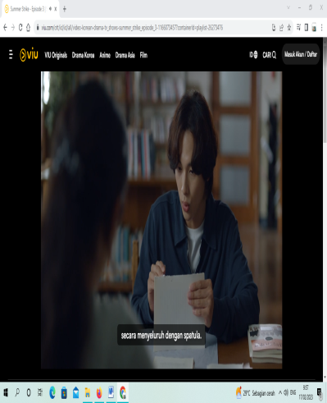 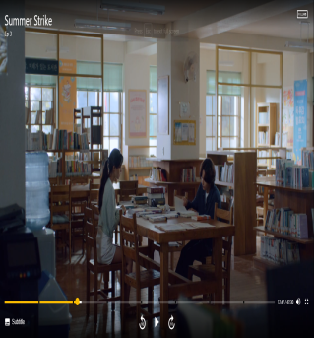

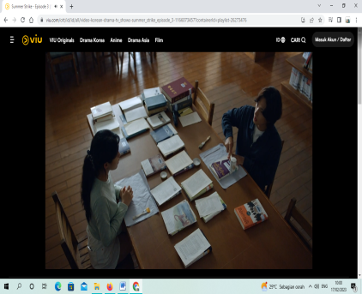

(**Episode 3, at minutes 00:12:35- 00:14:48)**

The scene cut above, in episode 3 at minutes 00:12:35- 00:14:48, shows the user and the librarian repairing the book. The librarian explains the series of book restoration activities step by step. Readers also try to repair the damaged books.

Describes users and librarians carrying out restoration activities and displays librarians who are experts in knowing the contents of books that are being repaired. The meaning of the film shows that a librarian has competence in the field of library science obtained through training, and is responsible for the entire contents of the library.

This pictorial representation shows the professional competence of librarians in carrying out information management tasks in the field of preservation.

### **Librarian Skills in Managing Library Materials**

Gambar 4.2 Librarian Skills in Managing Library Materials



**(Episode 3, at minutes 00:47:30)**



**(Episode 6, at minutes 00:25:19)**



**(Episode 12, at minutes 00:36:09)**

The scene above, the first image in the episode 3 minutes to 00:47:30, shows a librarian checking damaged library materials. The second picture in episode 6 minutes to 00:25:19, namely two librarians carrying out library material recording activities. The third picture in the 12th episode, minute 00:36:09, presents the activities of attaching book barcodes carried out by librarians.

The three different episodes describe the library material processing activities starting from checking activities, recording additions to library materials to attaching book barcode labels. The meaning of the film shows that the two librarians are trained and responsible for caring for the library and its contents, including selecting and processing library materials, with the aim of facilitating service to users.

This pictorial representation shows the professional competence of librarians in carrying out information management tasks in the field of processing library materials whose activities include: selecting, recording, listing. This scene can be described as competent in the profession of library science.

### **Librarian Skills in Technology**

### Gambar 4.3 Librarian Skills in Technology

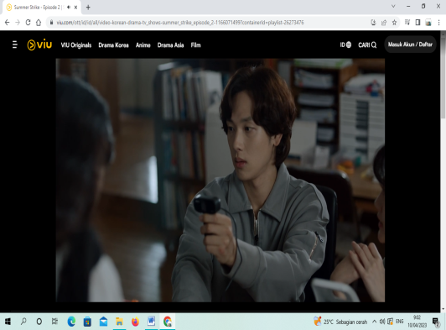

**(Episode 3, at minutes 00:12:10)**



**(Episode 6, at minutes 00:39:20)**

The scene above, in episodes 3 and 6 at the 00:12:10 and 00:39:20 minutes, shows the librarian scanning the user's face using DNMR 360 webcam technology, which is a digital camera to take pictures when making a library membership card. . The librarian can be seen using a barcode scanner system behind the books.

This scene illustrates the skills and abilities of librarians in providing circulation services where librarians are experts in using scanning technology. In the picture it can be seen that the Angok library is located in a small town or what is called a village where the library is sophisticated using technology. The meaning of the film shows that librarians are skilled in the field of technology in providing circulation services using barcode scanner technology. This technology can transfer barcode data that can work with library databases so that it can be used in library transactions.

The representation in this picture shows the professional competence of librarians in circulation services by using barcode system technology which will make it easier and faster to service and return books. The episode clip depicts a librarian who is competent in the field of technology. This means that libraries nowadays use a lot of technology.

### **Librarian’s Knowledge**

Gambar 4.4 Librarian’s Knowledge

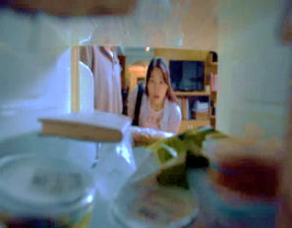  

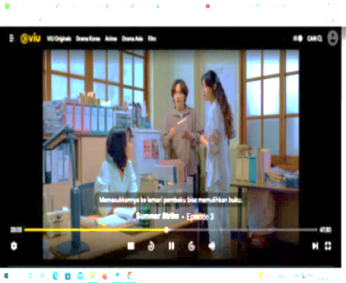

**(Episode 3, at minutes 00: 22: 43-00:23:10)**

The scene cut above, in episode 3 at minute 00:22:43 - 00:23:10, shows that the user is shocked when the book is wet and then recovered by putting it in the freezer. The librarian explains to the reader in detail the content of paper, namely the properties of cellulose.

This scene illustrates that the librarian has an understanding of the chemical content of paper. This means that librarians not only study in the field of library science, but librarians are also able to study all scientific disciplines related to books and libraries. The meaning of the film shows librarians as distributors of intellectual (knowledge) so that they can provide information according to the knowledge they apply and can convey it to the library according to their information needs..

This representation shows the professional competence of librarians who have knowledge of science so they can disseminate the knowledge they have to readers. Librarians are described as resources that can be trusted to manage knowledge or information.

### **Librarian Expertise in the Field of Science**

Gambar 4.5 Librarian Expertise in the Field of Science

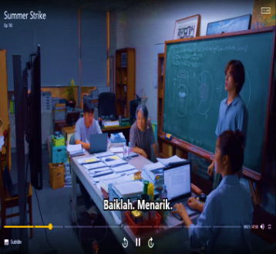  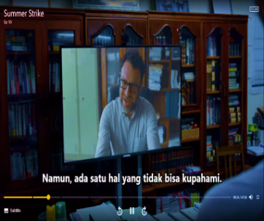

In the scene cut above, in the first picture of Episode 10 at minute 00:09:13 - 00:10:03, seen in the first picture, Ahn Dae Bum (Librarian) is presenting the entropy formula in front of the professors using English. Ahn Dae Bum (librarian) is also seen looking for and finding information in the library.

In this scene, the first picture depicts a librarian who is not only an expert in the field of library science but also has mastered knowledge in the field of chemistry.

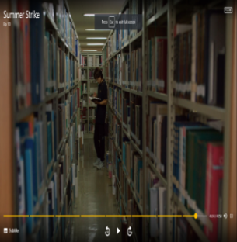 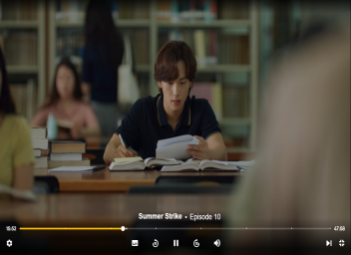

**(Episode 10, at minutes 00:09:13- 00:10:15)**

In the second picture the librarian searches and finds information about chemistry. The meaning of the film shows that librarians are not only experts in the field of library science, but librarians can also study knowledge in other fields. Therefore, the library is a place where all knowledge is collected. Librarians must study in other fields to be able to transfer their knowledge.

This pictorial representation shows the competence of librarians in mastering other knowledge. Some people think that a librarian's job is only to look after books but they must be able to master various kinds of knowledge. A librarian must also have the spirit of a lifelong learner so that he can provide knowledge and intelligence to the community.

## **Personal Competencies of Librarians Depicted by the Film Summer Strike**

Individual competencies are grouped into attitudes and communication, attention and care of librarians and transformation of librarian behavior, in the film Summer Strike.

### **Librarian Personality**

Picture 4.6 Librarian Personality

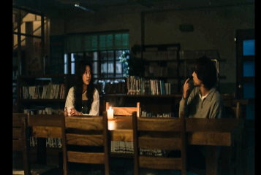 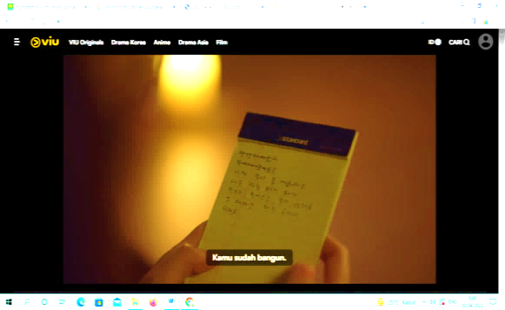

**(Episode 2, at minutes 00:40:44 - 00:41:11)**

The scene cut above, in episode 2 at minute 00:40:44 - 00:41:11, shows the librarian and the user trapped in the library. When the user began to wake up from the influence of alcohol, he asked why he was in the library. Librarians only communicate non-verbally via paper. The librarian thought librarians couldn't talk.

The scene depicts a librarian who is quiet (introverted) and communicates with users using body language without making a sound. The meaning of the film shows that the librarian's personality is too closed. This does not reflect the basic attitude of librarians providing services to users. The bad image of librarians can be hindered by the quality of service because of the librarian's personality.

The representation of this image shows a personality that is not competent in providing services. The librarian's personality should be polite, courteous, and have good interactions in providing services.

### **The Librarian’s Attention Attitude**

Picture 4.7 The librarian’s attention attitude

 

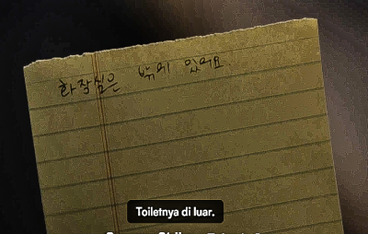

(**Episode 2, at minute00:39:50- 00:48:01)**

In the scene cut above, in episode 2 at minutes 00:40:44 - 00:41:11, you can see the librarian and the user trapped in the library. When the user began to wake up from the influence of alcohol, he asked why he was in the library. Librarians only communicate non-verbally via paper. The librarian thought librarians couldn't talk.

In this scene, the librarian pays attention to the user, when the user starts to become aware, he gives them mineral water and a blanket. When the librarian wanted to ask about the toilet, the librarian just answered that the toilet was outside and waited for the door to open at 8 am. The meaning of the film shows the librarian's caring attitude towards the difficulties of the library by providing blankets and mineral water without any strings attached.

This representation shows the competence of librarians who have a caring attitude towards librarians who experience difficulties without any strings attached. Because some people view the attitude of librarians both in the real world and in the film world, many people point out that librarians lack attention towards users. In the complaints of users.

### **Librarian’s Caring**

Gambar 4.8 Librarian’s Caring

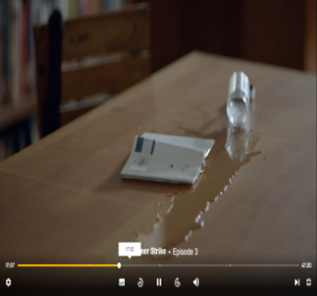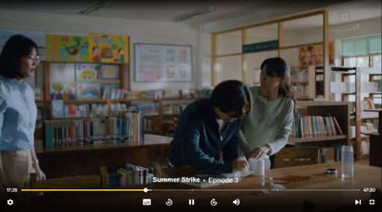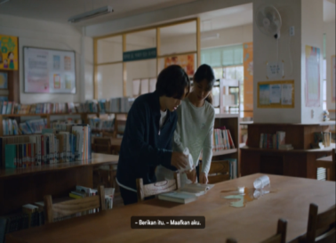

**(Episode ke 3, at minute 00:17:00 -00:17:32)**

In the scene cut above, in the 3rd episode at the 00:17:00 -00:17:32 minute, the book is seen being spilled and the librarian is shocked to see the book. The librarian quickly approaches and immediately dries the book with a tissue.

This scene illustrates the caring attitude and responsibility of librarians towards library materials. The meaning of the film shows librarians' concern for library materials that have spilled water. It can be seen in the film footage that librarians have a caring, responsible and professional attitude towards the tasks they carry out.

This representation shows the competence of librarians who have a caring attitude towards library material collections. Librarians also involve themselves in helping library users who experience difficulties.

### **Transformation of Librarian Behavior**

Gambar 4.9 Transformation of librarian behavior

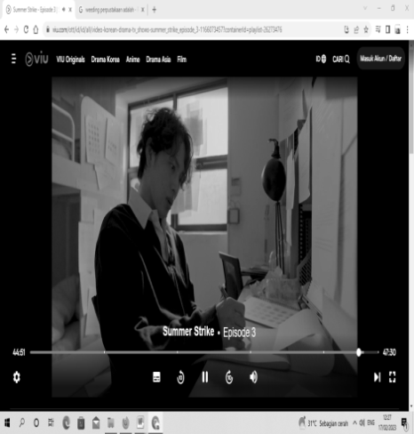

**(Episode 3, at minutes 00:47:30)**

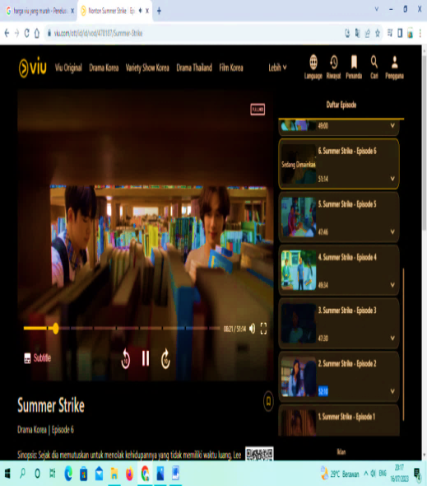 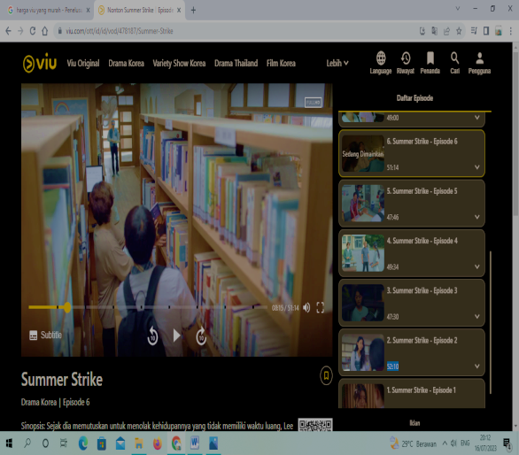

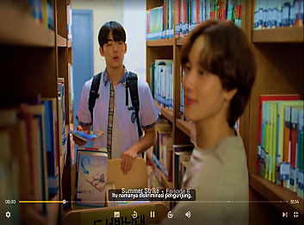

**(Episode 6, at minute 00:08:01 -00:08:31)**

In the scene above, in the 3rd episode at minute 00:47:30 Ahn Dae Bum remembers the trauma he experienced in the past. In the second picture of Episode 6, duration 00:08:01 -00:08:31, Jae Hoon and Ahn Dae Bum are returning books on the shelf. Jae Hoon talks about the visitors who often come to the library.

In this scene, the librarian remembers events from his past and realizes that his personality is closed due to his past. The librarian began to interact and communicate with the librarian. You can see that the librarian asked the librarian and the librarian answered well. So the meaning in the film shows that librarians can realize their character. It can be seen in this second scene that the interaction between librarian and user services is not rigid, so that users will feel well served. This shows the librarian's ability to improve the service attitude of librarians with a positive image.

This pictorial representation shows changes in librarian behavior, it can be seen that librarians can interact well and friendly and engage in conversation with users.

**CONSLUSION**

The analysis that has been carried out by researchers on the image of librarians in the film Summer Strike uses Roland Barthes' semiotic analysis approach in the form of a composition of 9 scenes that represent librarians. Researchers can draw the following conclusions:

1. Representation of the professional competence of librarians depicted in the Summer Strike film is that librarians are skilled and expert in caring for libraries and their contents including selection, processing of library materials, preservation, experts in technology. Aims to simplify service to users. This summer strike film also shows the knowledge of librarians regarding the contents of paper and librarians can channel their knowledge to users, so librarians can be said to be intellectual actors so they can provide information according to the knowledge they apply and can convey it to users. The film Summer Strike depicts that librarians are not only experts in the field of library science, but librarians can also study knowledge in other fields such as science.
2. The representation of Personal Competence depicted in the film Summer Strike is that the attitudes and interactions of librarians are too closed. This does not reflect the basic attitude of librarians in implementing the code of ethics. Even though the librarian's attitude is closed, there is still a positive attitude that is highlighted by the librarian, namely the librarian's attention and concern for the library and collections and being selflessly involved in helping the library's difficulties. The summer strike film also depicts changes in librarians' attitudes, librarians quickly realized and changed their behavior for the better.

**References**

Azmar, Nora Junita. “*Peran Pustakawan Dalam Meningkatkan Kualitas Layanan Di Perpustakaan.”* Iqra’: Jurnal Perpustakaan Dan Informasi Vol. 9, No. No. 2 (2015): Hal.225.

Barthes, Roland. *The Semiotics Challenge*. New York: Hill And Wang, 1998.

Basuki, Sulityo. *Pengantar Ilmu Perpustakaan.* Tanggerang: Universitas Terbuka, 2013.

Buwana, Radiya Wira. *“Membentuk Sikap Pelayanan Pustakawan Yang Bercitra Positif.”* Jurnal Kajian Informasi Dan Perpustakaan 8, No. 2 (2020). Https://Doi.Org/10.24198/Jkip.V3i1.10274.

Djuwarnik. “*Peranan Jejaring Perpustakaan Dalam Meningkatkan Kompetensi Pustakawan.”* Surabaya: Dalam Prosiding: Forum Perpustakaan Perguruan Tinggi Indonesia Jawa Timur, 2013.

Gutsche, Betha. “*Pengembangan Manajemen : Mempersiapkan Dan Mengembangkan Calon Manajer Yang Efektif.”* Bandung : Alfabeta Keputusan Menteri Tenaga Kerja Dan Transmigrasi Republik Indonesia No. 83 Tahun 2012.Mengenai Skkni Bidang Perpustakaan, 2016.

Hall, S, And O University. *Representation: Cultural Representations And Signifying Practices. Comm1107*: Sage Publications, 1997.

Hernandono. “*Meretas Kebuntuan Kepustakawanan Indonesia Dilihat Dari Sisi Sumber Daya Tenaga Perpustakaan.”* Makalah Orasi Ilmiah Dan Pengukuhan Pustakawan Utama . Perpustakaan Nasional : Jakarta., 2005.

Junaedi, Fajar. *Komunikasi Massa Pengantar Teoritis*. Jogjakarta: Penerbit Santusta., 2007.

Kurniawan. *Semiologi Roland Barthes. Magelang* : Yayasan Indonesia, 2001.

Lasa Hs. *“Pustakawan Sebagai Tenaga Kependidikan* : Peluang Dan Tantangan.” Yogyakarta, 2009.

Manajemen Sumber Daya Manusia: *Menciptakan Keunggulan Bersaing Berbasis Kompetensisdm*. Yogyakarta: Andi, 2015.

Ngatini. “Pelayanan Prima : *Upaya Pustakawan Dalam Meningkatkan Kualitas Pelayanan.”* Buletin Perpustakaan Universitas Islam Indonesia 1, No. 1 (2018): 53–70. Https://Journal.Uii.Ac.Id/Buletin-Perpustakaan/Article/View/11500/8671.

Noor Mas, Idham, Firdaus Azwar Ersyad, Firdaus Azwar Ersyad, And Kharisma Ayu Febriana. “*Representasi Bullying Melalui Lirik Lagu Gajah Karya Tulus.”* Eskripsi Usm, 2019. Https://Eskripsi.Usm.Ac.Id/Home.Html.

Putra, Mustika. *“Profesionalisme Pustakawan.”* Buletin Perpuatakaan Uii 1, No. 57 (2017): 27–35. Https://Journal.Uii.Ac.Id/Buletin-Perpustakaan/Article/View/9097.

S, Hermawan Rachman, And Zulfikar Zein. *“Kode Etik Kepustakawanan: Suatu Pendekatan terhadap Kode Etik Pustakawan Indonesia.”* Jakarta: Sagung Seto, 2006.

Sarasawitri, Nada Auliya, Atiqa Nur Latifa, Hanum Program, Studi Diploma, Perpustakaan Fkip, And Untan Pontianak. “*Peran Pustakawan Sebagai Edukator Dalam Layanan Penelusuran Informasi Di Perpustakaan Universitas Tanjungpura.”* Jurnal Pendidikan Dan Pembelajaran Khatulistiwa 8, No. 10 (2019): 1–8. Https://Jurnal.Untan.Ac.Id/Index.Php/Jpdpb/Article/View/36187.

Tri Dan Hudaniah, Dayakisni. *Psikologi Sosial.* 2nd Ed. Malang: Umm Press, 2003.

“Undang-Undang Republik Indonesia Nomor 43 Tahun 2007 Tentang Perpustakaan,” 2007. Http://Digilib.Isi.Ac.Id/2667/1/Uu-43-2007-Perpustakaan.Pdf.

Uswatun, Ade. “*Pustakawan Masa Kini.” Iqra: Jurnal Ilmu Perpustakaan Dan Informasi (E* … 10, No. 01 (2016). Http://Jurnal.Uinsu.Ac.Id/Index.Php/Iqra/Article/View/126%0ahttp://Jurnal.Uinsu.Ac.Id/Index.Php/Iqra/Article/Viewfile/126/106.

Wahyuni, M. *“Peran Pustakawan Sebagai Penyedia Informasi.”* Iqra, Jurnal 09, No. 02 (2015): 39–53. Http://Jurnal.Uinsu.Ac.Id/Index.Php/Iqra/Article/Viewfile/73/225.

1. “Undang-Undang Republik Indonesia Nomor 43 Tahun 2007 Tentang Perpustakaan,” 2007, http://digilib.isi.ac.id/2667/1/UU-43-2007-PERPUSTAKAAN.pdf.
2. Mustika Putra, “Profesionalisme Pustakawan,” *Buletin Perpuatakaan UII* 1, no. 57 (2017): 27–35, https://journal.uii.ac.id/Buletin-Perpustakaan/article/view/9097.
3. Nora Junita Azmar, “*Peran Pustakawan Dalam Meningkatkan Kualitas Layanan Di Perpustakaan*,” Iqra’*:* Jurnal Perpustakaan Dan Informasi. Vol. 9, No. 2 (2015): hal.225.
4. Ade Uswatun, *“Pustakawan Masa Kini,” IQRA: Jurnal Ilmu Perpustakaan Dan Informasi (e …* 10, no. 01 (2016), http://jurnal.uinsu.ac.id/index.php/iqra/article/view/126%0Ahttp://jurnal.uinsu.ac.id/index.php/iqra/article/viewFile/126/106.
5. “Undang-Undang Republik Indonesia Nomor 43 Tahun 2007 Tentang Perpustakaan.”
6. Sulityo Basuki, "*Pengantar Ilmu Perpustakaan ".* (Tanggerang: *Universitas Terbuka*, 2013).
7. Putra, “Profesionalisme Pustakawan.”
8. Nada Auliya Sarasawitri et al., “Peran Pustakawan Sebagai Edukator Dalam Layanan Penelusuran Informasi Di Perpustakaan Universitas Tanjungpura,” *Jurnal Pendidikan Dan Pembelajaran Khatulistiwa* 8, no. 10 (2019): 1–8, https://jurnal.untan.ac.id/index.php/jpdpb/article/view/36187.
9. Djuwarnik, “Peranan Jejaring Perpustakaan Dalam Meningkatkan Kompetensi Pustakawan.”
10. Lasa Hs, “Pustakawan Sebagai Tenaga Kependidikan : Peluang Dan Tantangan.” (Yogyakarta, 2009).
11. M. Wahyuni, *“Peran Pustakawan Sebagai Penyedia Informasi*,” *Iqra, Jurnal* 09, no. 02 (2015): 39–53, http://jurnal.uinsu.ac.id/index.php/iqra/article/viewFile/73/225.
12. Hermawan Rachman S and Zulfikar Zein., “Kode Etik Kepustakawanan: Suatu Pendekatanterhadap Kode Etik Pustakawan Indonesia.” (Jakarta: Sagung seto, 2006).
13. Radiya Wira Buwana, “Membentuk Sikap Pelayanan Pustakawan Yang Bercitra Positif,” *Jurnal Kajian Informasi Dan Perpustakaan* 8, no. 2 (2020), https://doi.org/10.24198/jkip.v3i1.10274.
14. Dayakisni, Tri dan Hudaniah, Psikologi Sosial, ed.2. (Malang: UMM Press, 2003).
15. Hall and University, *Representation: Cultural Representations and Signifying Practices*.
16. Idham Noor Mas et al., “*Representasi Bullying Melalui Lirik Lagu Gajah Karya Tulus,”* *ESkripsi USM* (2019), https://eskripsi.usm.ac.id/home.html.
17. Roland. Barthes, *The Semiotics Challenge.* (New York: Hill and Wang, 1998).
18. Fajar Junaedi, Komunikasi Massa Pengantar Teoritis. (Jogjakarta: Penerbit Santusta., 2007).
19. Kurniawan, Semiologi Roland Barthes. (Magelang: Yayasan Indonesia, 2001).